SUSTAINABLE, RESILLIENT USE CASES
TEMPLATE to collect USE CASES
D3.3.2.6 Sustainable, resillient use cases

Version 1

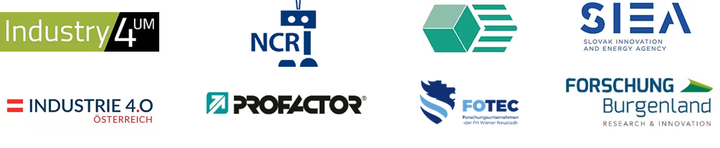

Use Case 1
TITEL OF THE USE CASE: | Flexible Automatisierung mit Cobots

TOPIC: | Sustainable, resillient production systems

CONTACT INFORMATION
Partner organisation: | RISE Research Institutes of Sweden
Contact person: | Behrooz Sangchoolie
Address: | Brinellgatan 4  Box 857  SE-501 15 Borås
E-mail: | behrooz.sangchoolie@ri.se
Phone: | +46 10 516 61 89

DESCRIPTION
Short summary of the Use Case:  Max.200 characters as promotional introduction | Unlike conventional industrial robots, collaborative robots, also called "cobots," work side by side with operators. The possibilities are countless: from pick-and-place operations on assembly lines to polishing. Sirris offers consulting to evaluate the use of cobots in the enterprise.  Cobots are designed to work safely with humans in a shared work environment. The principle: create an additional worker to assist the operator with specific tasks. These tasks might include lifting heavy loads or performing repetitive tasks. Pick-and-place operations and (light) assembly work are also common. Although there are cobots that perform tasks that require a "sense of touch," such as polishing. Cobots can therefore be used in a wide variety of industries to perform a whole range of tasks.  The advantages of cobots Easy programming: for certain applications, the cobot can be taught certain routines via the teach-by-demonstration function.
Detailed information on the Use Case:  Max.1000 characters about technical features – easy language | Safe: The cobot can detect external forces thanks to integrated sensors. It can automatically slow down or stop if the force is too great. The operator can simply stop it by hand. Therefore, the cobot can work safely with humans in certain situations.  Plug & Produce: cobots can be easily moved and integrated into various production processes.  Versatile: Cobots can be used in various tasks: for example, as an operator's third hand or for assembly and installation tasks or for loading or unloading machines or as a tool gripper, etc.  Pricing: Cobots are almost always cheaper and easier to deploy and therefore within the scope of smaller companies.  Open system: Different cobot types can be programmed via the "Robot Operating System" (ROS). This allows faster integration with other systems, including mobile platforms.
Key achievements:  Results of the application for SME e.g. new market entry | Benefits for the cooperation area  Thematically good development potentials for the cooperation area SK-AT;  Program and project options for funding twinnings.
Further information:
Link to further information on the case study can be found
Keywords related to your case study: | Cobots, production
Visual presentation:  Image (2000px wide recommended) and/or videeo | 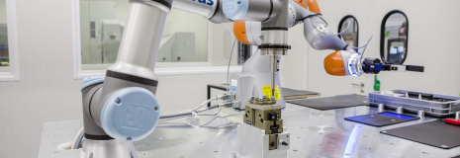
Resources needed:
Please specify the human resources required to set up and to run the case study. Do you need any external experiences to implement the case study? If yes, please specify.

