SUSTAINABLE, RESILLIENT USE CASES
TEMPLATE to collect USE CASES
D3.3.2.6 Sustainable, resillient use cases

Version 1

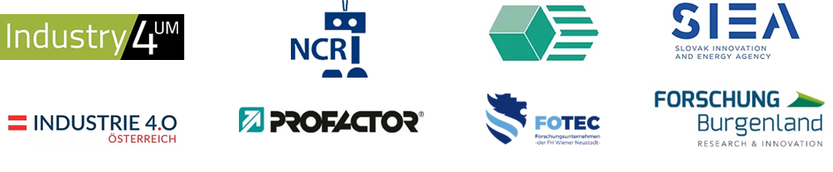

Use Case 1
TITEL OF THE USE CASE: | Amadeus: Mobiles Robotersystem für die Intralogistik

TOPIC: | Inbdsutrial assistance systems

CONTACT INFORMATION
Partner organisation: | Frauenhofer-Institut für Produktionstechnik und Automatisierung IPA
Contact person: | M.Sc. Richard Bormann
Address: | Nobelstr. 12  70569 Stuttgart
E-mail: | Richard.Bormann@ipa.fraunhofer.de
Phone: | +49 711 970-1062

DESCRIPTION
Short summary of the Use Case:  Max.200 characters as promotional introduction | To make production environments more flexible and adaptive, the Amadeus system has been developed, a combination of autonomously navigating robot system, integrated robot arm and Manufacturing Execution System (MES).
Detailed information on the Use Case:  Max.1000 characters about technical features – easy language | The developed system offers a completely new solution approach for in-plant material handling and material transport. It can support production processes in an automated way and is highly flexible: The free navigability with automated path finding and the variable design of the application-specific setup open up a wide range of tasks and many possible applications. The system's performance was evaluated using the scenarios "machine placement" and "part provisioning at manual assembly workstations".  The consortium of the publicly funded project consisted of the companies acp-IT, Faude, SNOX as well as Fraunhofer IPA as the project coordinator responsible for the integration of subcomponents and realization of selected application scenarios.
Key achievements:  Results of the application for SME e.g. new market entry | Benefits for the cooperation area  Knowledge transfer for the production core areas in SK-AT;  Direct benefits through innovation and adaptive development work.
Further information:  Link to further information on the case study can be found | https://www.ipa.fraunhofer.de/de/referenzprojekte/Amadeus.html
Keywords related to your case study: | Cobots, human-robot interaction. Logistics
Visual presentation:  Image (2000px wide recommended) and/or videeo | 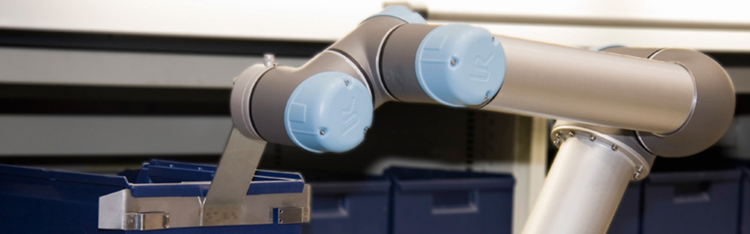
Resources needed:
Please specify the human resources required to set up and to run the case study. Do you need any external experiences to implement the case study? If yes, please specify.

