Share4.0
WoRkpackage report
D2.4.3 – e-book

Industry 4.0 level of enterprise
Združenie inteligentného priemyslu – Industry4UM
Date 28.11.2022

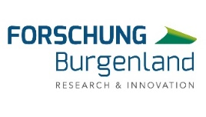

SURVEY PARAMETERS

Focus | survey focused on the industrial enterprises with Slovak and foreign capital
Vintage | Fifth year
Method  of implementation | electronic form
Collect responses | August - October 2021
Number  of questions | 23 questions - closed questions, combined with open questions
Number  of respondents | 125 respondents
Notes | the survey is time-lapse - repetition in the coming years for capturing trends and tracking developments

RESUME
The Cluster Smart Industry Association - Industry4UM carried out the 5th annual survey on the level of implementation of Industry 4.0 in industrial enterprises in the months of August - October. The survey of 125 enterprises confirmed the trend of declining the pace of digitalisation and revealed the unpreparedness of the top management of Slovak enterprises for transformational changes. The attitude of senior management to Industry 4.0 in businesses is a metabarier that influences the next steps on the path to change. Problems remain with the preparation of the transformation strategy, the training of employees, and the building application teams.
According to the findings, 26% of enterprises are already implementing Industry 4.0, which can be perceived as a stagnation in the year-to-year comparison (2020 –25%). Almost half of businesses (47%) have not yet started implementing it. Industry 4.0 is considered very important for their future by 46% of businesses, which is a dramatic drop from the last year's 74% share. Enterprises implement it themselves without an external cooperation (20%) or consult it with one or two external consultants (22%). 34% of enterprises have a strategy ready, start using it or apply it to the fullest. More than 53% of companies with foreign capital have an application team, while only 24% with Slovak enterprises.

Enterprises see the need to digitize primarily in production processes and logistics and in cooperation with customers, suppliers, and consumers. Of those who do not see the importance of Industry 4.0 for the future of their businesses, managers and top managers make up a staggering 70%. Of the group of enterprises that have not yet implemented, 85% see the need of implementation. According to the survey, the managers themselves are the barriers for the implementation of Industry 4.0.

For the second year in a row, the COVID-19 pandemic is the major factor for the stagnation of transformational changes in businesses. Enterprises are aware of the importance of digitalisation in connection with the corona crisis, 51% of them confirmed that they would be helped by more significant digitalisation and automation in the current situation. Of the enterprises that have already started the transformation, 48% continue to transform as before the pandemic, 20% implement even more intensively, and almost a quarter limited their transformation. The corona crisis has put businesses in uncertainty and they cannot estimate its impact. Up to 72% of companies do not know how the corona crisis will affect the implementation of Industry 4.0 in their corporate processes and management.

The current dynamic changes in the labour market in relation to Industry 4.0 will require reshaping of existing jobs, the emergence of new positions with a significant demand for new skills. 42% of enterprises have confirmed that digital skills will be a key resource for the future and that strengthening employees' knowledge and skills will be a priority to take advantage of the possibilities of digitising the business. More than 30% of enterprises perceive the need of employees’ improvement in the knowledge of applications, processes, and technologies.

The progress in acquiring specialized knowledge and skills is directly proportional to the scope and quality of further adult education. In this area, however, it must be stated that only 22% of respondents have built a functioning system of further education of their employees.

In a detailed view of companies that do not implement Industry 4.0, it can be seen that it is largely made up of managers of enterprises with Slovak capital, who, although they see the need of applying Industry 4.0 to processes, do not have enough information about transformational changes, do not have a clear opinion on the importance of the application, and do not create implementation teams.

Digitalisation has entered our market very dynamically. People in factories were caught unprepared. This is a huge change that every business that wants to survive will have to go through. Business management currently lacks the vision and skills to where and how they should run their businesses. There is a lack of data management experts, data analysts, a lack of integration specialists and many others. The school system produces only a fraction of the needed graduates. There is almost no government support compared to neighbouring countries. We consider the situation to be critical.

FINDINGS
Industry 4.0 and digital transformation are accompanied with changes that take place with varying intensity and scale in our enterprises as well. The survey on the level of digitalisation has revealed some key findings.

1. Digitalisation of industrial enterprises stagnates
2. Top managers are the barrier to digital transformation.
3. The application of Industry 4.0 is very uneven, lacks implementation strategies and application teams
4. Corona crisis has put enterprises into uncertainty
5. Stagnation of implementation is exacerbated by insufficient education of graduates and employees
6. There will be demand for specialists in digitalisation, artificial intelligence, industrial engineering and automation

1. Digitalisation of industrial enterprises stagnates
Where are you with Industry 4.0?
A survey on the progress of Industry 4.0 and digital transformation in industrial enterprises has shown that the will of enterprises to digitise is declining. When asked where are they with Industry 4.0, 42% of enterprises said they haven't started yet. Only 17% of businesses are fully digitized, 9% of businesses are starting the digitalisation, and 8% are building their own strategy.

Where are you with Industry 4.0?
Answer - we have a strategy, and we are implementing it
The share of companies that started industry 4.0 is declining for the second year in a row. From the point of view of trends, the implementation in parameters – we have a strategy ready, we start with the application, and we fully implement our strategy – still keeps a slightly upward trend.

Your opinion on the importance of Industry 4.0 for your company's needs
It is very important for the future
Expressing an opinion on the importance of Industry 4.0 in the parameter - very important for the future - the survey this year captured a significant decrease, from 74% in the year 2020 to 46% in the year 2021. The downward
trend in the importance of applying transformational changes under the influence of Industry 4.0 was also confirmed with the view on the data captured over five years.
We prepare or adopt a strategy and apply it
23% of foreign capital enterprises and 10% of Slovak owners' enterprises have adopted a strategy, starting with the application, or are already applying it according to their own strategy. The difference in application in terms of capital structure is, as in previous years, significant and worrying. While Slovak enterprises are stagnating compared to the last year, enterprises with foreign owners in the application have seen a decline.

Detail of respondents who have not yet started the Industry 4.0 application
Of the total number of respondents, more than half (52%) of businesses did not start the Industry 4.0 application. This group consists of a surprisingly large part (67%) managers and top managers of enterprises and up to 67% of enterprises with Slovak capital. Despite the fact that a significant 85% of enterprises in the tracking group of respondents see the need of applying Industry 4.0, 67% of enterprises do not consider necessary to create imple-mentation and expert teams focused on applying changes; almost half (47%) do not have a firm opinion on the importance of Industry 4.0, they lack an idea on the investment complexity of implementation (67%) and do not have enough information or don’t know where to look for them (32%).

2. Top Managers are the barrier to digital transformation
Distribution of respondents who do not see the importance of Industry 4.0 for the future
Of those who do not see the importance of Industry 4.0 for the future of their businesses, managers and top managers make up a staggering 70%. Managers are not yet sufficiently aware of the potential, importance, and benefits of digital transformation at all levels of the enterprise, their application myopia slows down the progress of change.

How do senior executives see the importance of Industry 4.0 for the future?
62% of top executives expressed that Industry 4.0 is not important for the future of a business or have not yet formed an opinion on it. There are many different reasons behind the management attitude. From a lack of understanding of its strategic and economic importance, to a resistance to change, insufficient skills and professional virtues of employees.

3. The application of Industry 4.0 is very uneven, lacks implementation strategies and application teams
Several companies with foreign capital fulfill the strategic programs of their parent companies. Some of them even set trends for the whole group.

Where are you with Industry 4.0?
Enterprises do not have implementation strategies in place. So far, 66% of enterprises have not started implementation, or have started to collect information, or have started making their first attempts and building their first own experiences.

We have or are creating a team tasked with solving Industry 4.0
(depending on the size of the companies)
In terms of the size of companies, large enterprises (over 250 employees) create industry 4.0 application teams with the largest share. With the decreasing size of a company, the share of enterprises building application teams decreases.

We have or are creating a team tasked with solving Industry 4.0
The teams in charge of the application of Industry 4.0 are created primarily in enterprises with foreign participation. More than half of the enterprises with foreign owners create or already have an application team. Slovak companies, due to the overall stagnation of the transformation, create application teams more slowly. In the same category, only 24% of enterprises have the teams built today.
Team in charge of Industry 4.0
The difference in ratio of creating expert teams between SME enterprises and large enterprises is more than worrying. The teams are created within only 24% of SME enterprises, in large enterprises the teams are created within 83% of enterprises.

4. Corona crisis has put businesses in uncertainty
How has the corona crisis affected your company's approach to digitalisation?
(selection of companies that have already started to implement or to prepare)

Despite the fact that the corona crisis has entered businesses, almost half of companies proceed with their planned activities continuously, a quarter have limited their planned activities in the field of digitalisation, and 20% continue more intensively than before. However, 72% of enterprises do not know how the coronary crisis will affect the implementation of Industry 4.0 elements into business processes.

How will the change caused by the corona crisis affect the implementation of Industry 4.0 elements into your business processes?

Do you think your company would be better prepared for the changes caused by the corona crisis if your processes were digitized and automated?

5. Stagnation of implementation is exacerbated by insufficient education of graduates and employees

How is the education of workers in your company managed and supported?

Already today, the demands on the specialized qualification of employees for the transformation of the company are increasing, and will continue to increase. Less than a third of companies organise internal or external education, and only almost a quarter have a functioning continuing education system in place. Strengthening employees' knowledge and skills in the field of digitalisation of the company will be a priority in the coming years.

6. There will be demand for specialists in digitalisation, artificial intelligence, industrial engineering and automation

In what area would it be appropriate to strengthen the knowledge and skills of your workers?

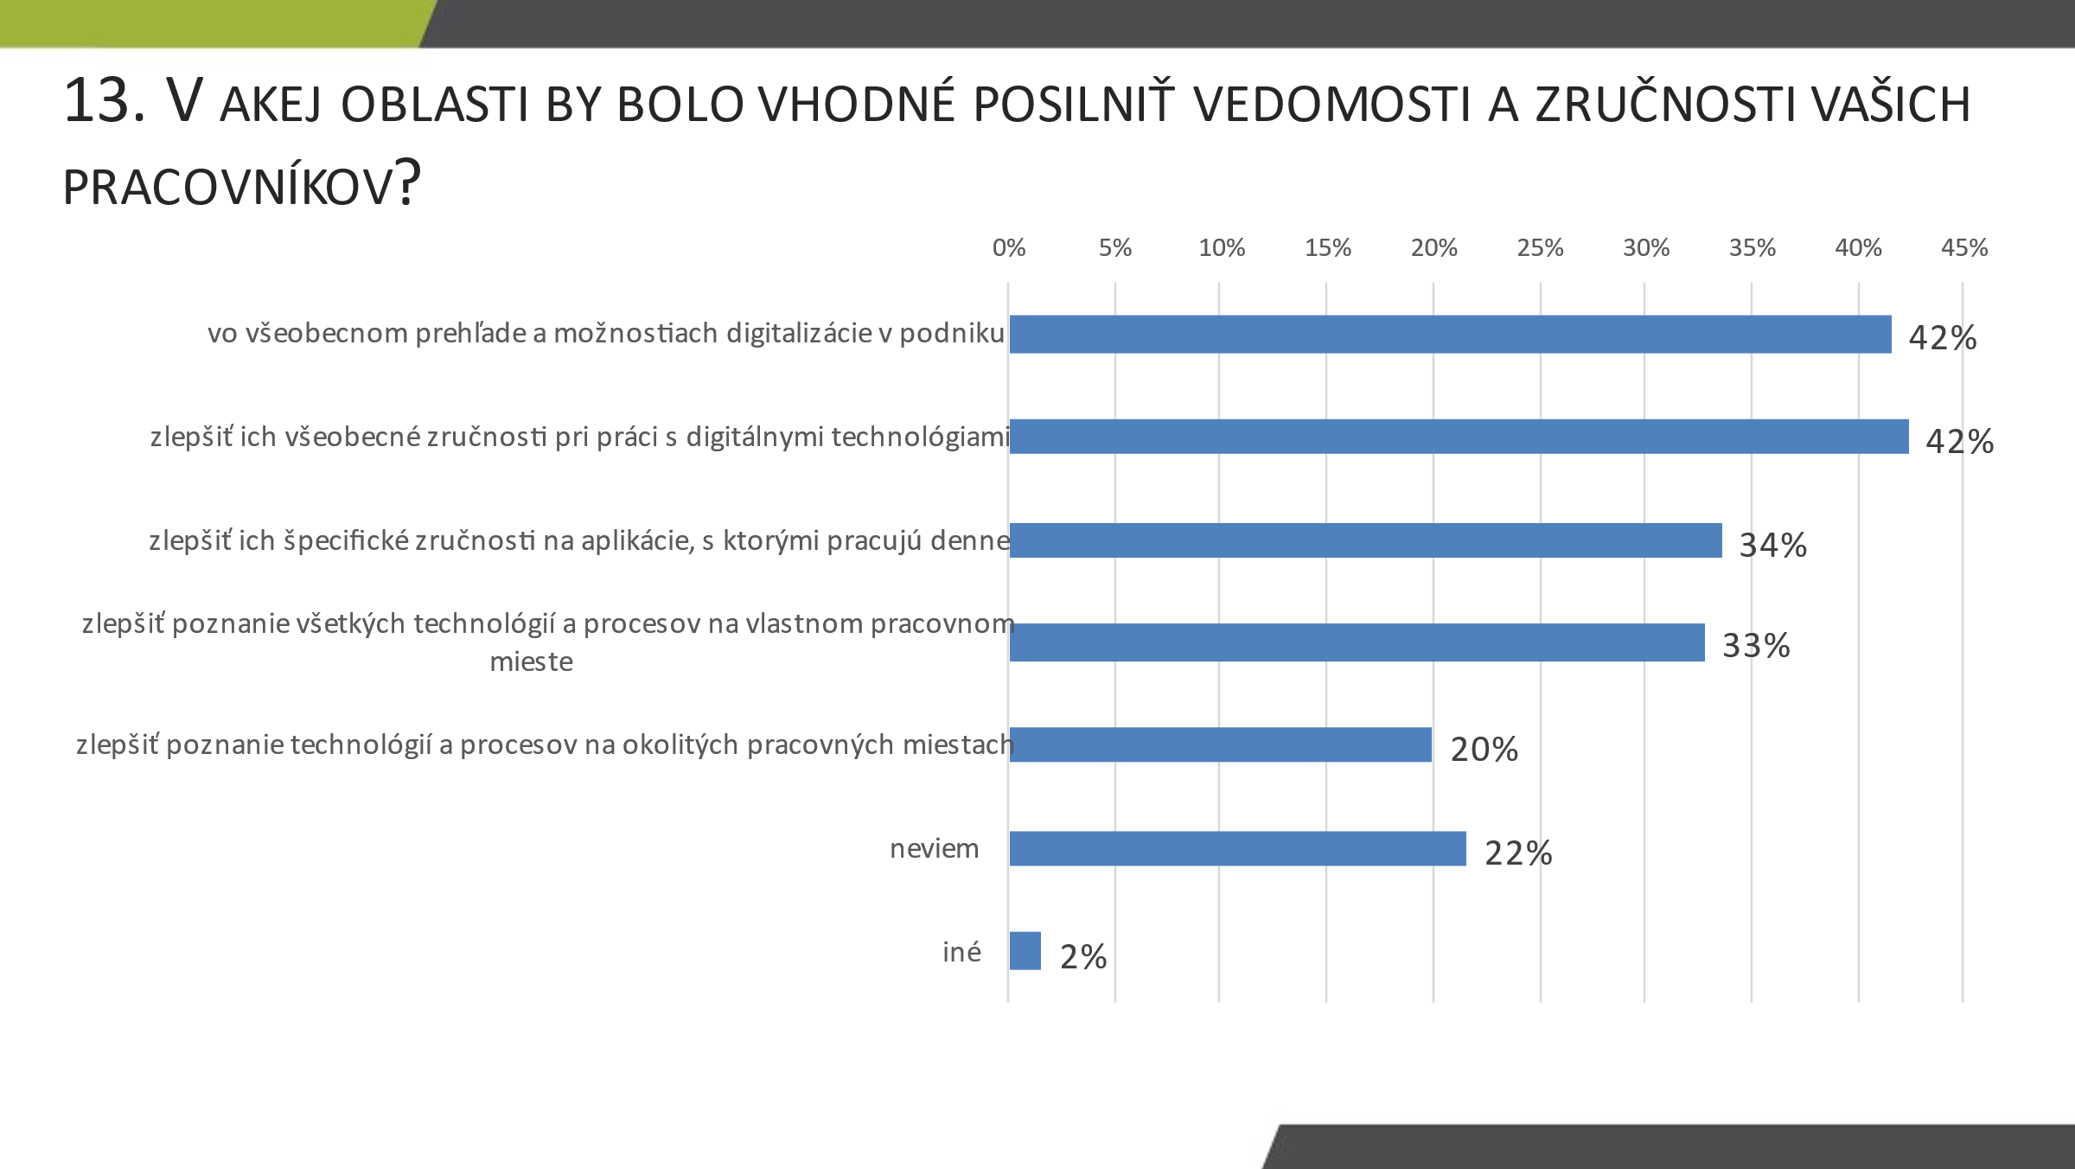
Digital skills will be a key requirement for employees for the future period. The greatest demand will be for specialists in the system solution of digitalisation, artificial intelligence, industrial engineering and automation.

In which of industry 4.0 technologies do you notice a shortage of skilled labour in specializations:
RECOMMENDATION
Industry 4.0 or digitalisation of industry is a trend considered worldwide as a major tool for the development of industry now and in the coming years. In the last two years, the survey revealed a decrease in the involvement of industry and government in this area, which can have serious negative consequences on the performance of the industry and the economy of Slovakia. We respond to the survey findings with the recommendations that are important to stop negative development:

- Development of knowledge and know-how at all levels of the enterprise

- Each company should develop its own know-how. It should have in place a way of collecting and exchanging information and in-house education with a focus on digitalisation
- It is appropriate to develop internal know-how through a team of authorised personnel. The task of the team is to collect and disseminate information within the company, to look for possibilities and opportunities of digitalisation and to work closely with the management of the company in the creation and application of the digitalisation strategy

- Top managers should be aware that Industry 4.0 is all about developing the business and economy of their companies and on this basis, they should orient their personal growth. They are responsible for the current and future competitiveness of the company and in this sense, they must also prepare a strategy for its development

- Small and medium-sized Slovak enterprises need an urgent help with the development of an implementation strategy

- Despite the fact that companies are aware of the importance of implementation, a critical part of Slovak companies is not able to implement it through prepared strategy
- The findings show that a large proportion of enterprises rely on one-off solutions without broader contexts and follow-ups, they do not plan a strategy in a longer term, the application is also complicated by the uncertainty arising from the current situation
- In business practice, there is little experience with the purposeful and successful implementation of Industry 4.0. It is therefore necessary to build a structure of supporting eco-systems and link them with enterprises

- Promoting the digitalisation of industry at state level

- The government should fundamentally support the digitalisation of industry. In almost all EU countries, there are Industry 4.0 platforms, functioning also with the support of the government. Extensive national programmes focused on Industry 4.0 are being implemented.
- Creation of support programmes for the development of small and medium-sized enterprises. It is important for businesses to be aware of the challenges and pitfalls of the current rapid acceleration of digitalisation, and to include digitalisation in their programmes not as an objective, but as a way of their further growth
- At present, there is no government activity that significantly supports Industry 4.0. The Slovak national programme "Smart Industry Strategy" has not been working for more than two years. The positive effects of amendment to Act No. 595/2003 on Income Tax of 27.10.2021, which also addresses the promotion of significant business investments in state-of-the-art technologies and processes with links to Industry 4.0, is inaccessible to the vast majority of enterprises. The launched grant calls for digitalisation cannot be considered systematic. No national industry 4.0 platform exists in Slovakia, and neither is in preparation.
- Systematic changes in education for digital transformation

The education and training of professionals is a broader problem that we have been drawing attention to for a long time. Despite the urgency of the problem, we still do not see sufficient systematic measures from the side of the competent institutions or businesses. In order to ensure adequate number of experts, it is necessary:
- Education should pay more attention to digitalisation at all levels of the education system within the framework of curricula and educational programmes
- It is essential to educate and build the skills of school graduates in cooperation with enterprises and in line with the needs of industrial practice
- The government should create conditions and support for the development of lifelong learning. This activity should help businesses to build up the necessary knowledge for digitalisation quite quickly and gradually retrain workers for the needs of the enterprise. An example is the Swedish Ingenjör 4.0 programme
- In Slovakia, we must realize that digital literacy will not be a privilege, but a necessity, while the implementation of Industry 4.0 will depend on specialists in various fields. Their digital prowess will determine the rate of the progress of businesses and our country as a whole

- We need to change the mindset of business management

- The main purpose of Industry 4.0 is to increase the competitiveness of companies through significantly improved management and decision-making
- Industry 4.0 thus directly touches the work of top management. Their task is to shift the attention of management from solving everyday problems and operational activities, to creating the future of a company and an agile organizational structure supporting transformation
- The frequency of changes in the market will grow, it will be necessary not only to react to them, but to develop businesses with a vision, and this is unattainable without comprehending digital management. Digitalisation is the main tool for developing or at least maintaining the competitiveness of companies at the moment – this is something that managers must not only be aware of, but must also start to push

