SUSTAINABLE, RESILLIENT USE CASES
TEMPLATE to collect USE CASES
D3.3.2.6 Sustainable, resillient use cases

Version 1

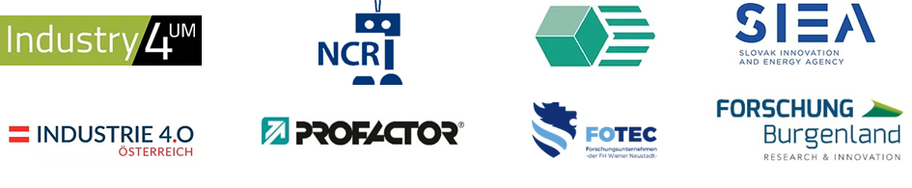

Use Case 1
TITEL OF THE USE CASE: | Amadeus: Mobiles Robotersystem für die Intralogistik

TOPIC: | Sustainable, resillient production systems

CONTACT INFORMATION
Partner organisation: | RISE Research Institutes of Sweden
Contact person: | Behrooz Sangchoolie
Address: | Brinellgatan 4  Box 857  SE-501 15 Borås
E-mail: | behrooz.sangchoolie@ri.se
Phone: | +46 10 516 61 89

DESCRIPTION
Short summary of the Use Case:  Max.200 characters as promotional introduction | Manufacturers of automated systems and the manufacturers of the components used in these systems have spent an enormous amount of time and effort in recent years developing and researching automated systems. The effort expended has led to the availability of prototypes demonstrating new capabilities and to the market introduction of such systems in various fields. Manufacturers of these systems must ensure that the systems function in the intended manner and according to specifications, which is not a trivial task as system complexity increases dramatically as these systems become more integrated and interconnected through the addition of automated functions and features.  As complexity increases, unknown new features of the system may surface, requiring thorough verification and validation (V&V) of these systems. By V&V of automated systems, the manufacturers of these systems are able to ensure safe and reliable systems for society, as failures in highly automated systems can be catastrophic.  The high complexity of automated systems causes extra effort for the V&V process, making it time consuming and costly. VALU3S aims to design, implement and evaluate state-of-the-art V&V methods and tools to reduce the time and cost of verifying and validating automated systems against security, cybersecurity and privacy (SCP) requirements. This will ensure that European manufacturers of automated systems remain competitive and global leaders. To this end, a multi-domain framework will be designed and evaluated with the goal of creating a clear structure around the components and elements needed to perform the V&V process by identifying and classifying evaluation methods, tools, environments, and concepts needed to verify and validate Validation of Automated Systems with respect to SCP Requirements.  In VALU3S, 12 use cases with specific security and privacy requirements are studied in detail. Several state-of-the-art V&V methods are investigated and further improved, in addition to implementing new methods aimed at reducing the time and cost required to perform V&V of automated systems. The investigated V&V methods will then be used to design improved process flows for V&V of automated systems. Several tools will be implemented to support the improved processes, which will be evaluated by qualifying and quantifying security, safety, privacy, and other evaluation criteria using demonstrators. VALU3S will also influence the development of security and privacy standards through active participation in related standards groups. VALU3S will provide guidance to the testing community, including engineers and researchers, on how the V&V of automated systems could be improved, taking into account the cost, time, and effort required to perform the tests.
Detailed information on the Use Case:  Max.1000 characters about technical features – easy language | . Human-robot interaction in partially automated assembly processes.  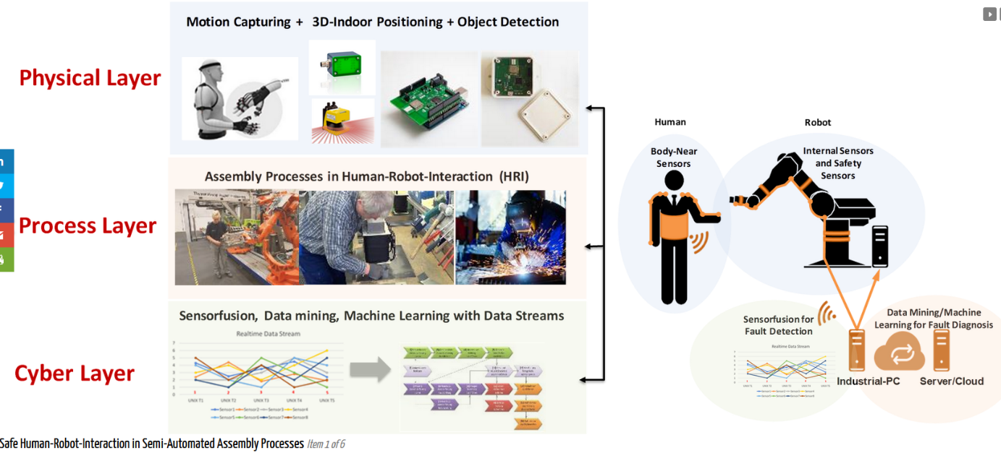  The use case takes place at the store floor level and focuses on real-time object tracking and recognition in industrial IoT environments. It is based on a wearable motion detection system combined with a low-power single-board computer for data pre-processing, sensor fusion and wireless transmission. The described system can be considered as a means for a broader range of demanding safety, security, and context-aware applications in IoT environments, such as collision avoidance.  The idea is to establish a real-time data stream processing pipeline to record external and internal sensor data from the HRI system. The goal of the use case scenario is to detect and identify errors in the data stream that may cause the collaborative robot to malfunction and injure the human worker. This forms the basis for extracting individual data segments from the stream and eventually detecting errors in the data patterns. These sequential patterns are labeled and stored in the cloud while providing the main input for performing machine learning techniques (classification or regression), typically neural networks or support vector machines.  Physical barriers that reduce risks when using robots.  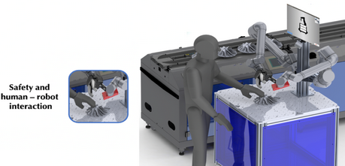  Currently, the EU Machinery Directive (U.S. OSHA (29 CFR 1910)) and other regulations require machine manufacturers to install safety measures to protect operators and other workers from hazards. In collaborative robotics, the standard prescribes the need to define four characteristics for a collaborative robot: (i) design of the collaborative workspace; (ii) definition of collaborative operation: minimum distance between robot and operator, maximum speed, static and dynamic limits, ergonomics; (iii) methods for collaborative work: safety-controlled stop, manual guidance, distance and speed control, etc.; and (iv) definition of the difference between collaborative/non-collaborative. The objective of the Fundación Aspace Navarra para el Empleo (FANE) organization is to meet the labor needs of people with disabilities in order to facilitate their integration into the common labor market. The VALU3S technology can facilitate the required thorough V&V activities by regulators for this type of technology by providing a validated platform for the systematic testing of complex software systems. The goal of this use case is to use the VALU3S in a collaborative robotics application.  Automated robotic inspection cell for automotive body-in-white quality control.  The objective of this use case is to provide a better fault-tolerant production line to achieve better quality control for automotive body-in-white. Quality control was performed using the camera system positioned on the Cartesian robot, which is located on both sides of the vehicle body (i.e., bus). The data obtained from the CAD data of the large vehicle is compared with the actual data obtained from the camera system, using the synthetic data obtained from the developed data, and the object presence/absence check and critical measurement checks acquired from sensors, and actuators. To ensure that VALU3S technology is applicable to the robotic inspection cell for quality control, we will address automated fault and attack injection in this use case, especially to control the entire automated industrial line.  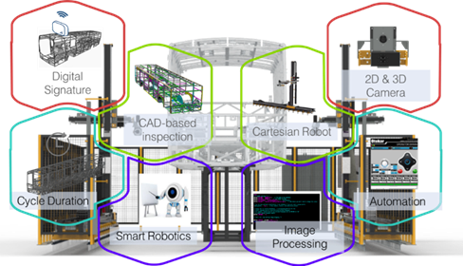  The use case will be evaluated in the context of VALU3S considering security and safety, e.g., demonstrating the results of simulations and the role of VALU3S in decision making, evaluating complete inspection processes in terms of task completion rate, duration, and safety metrics, considering the time required to detect and overcome faults and attacks, and anomaly detection at the component and system level by leveraging ML techniques.  Automated robot inspection cell for quality control of automotive Industrial Drives for Motion Control.  The Industrial Drives for Motion Control use case focuses on a generic commercial motion control platform solution for permanent magnet synchronous motors. The available system for this case study has already been developed in SESAMO and AQUAS-ECSEL projects to meet the IEC 61508 and IEC 62443 safety standards from a safety perspective. An FPGA-based hardware prototype and a virtual prototype are available as a basis for VALU3S. VALU3S perfectly complements the previous work regarding the V&V focus. In particular, the transition to the new processor architecture causes a significant verification effort of safety and security features, where effective fault and attack injection can bring high value.
Key achievements:  Results of the application for SME e.g. new market entry | Benefits for the cooperation area  Knowledge transfer and competence building/expansion for fault detection systems in collaborative robotics;  Expansion of the European work base due to the large number of use cases and collaborating actors.
Further information:  Link to further information on the case study can be found | https://valu3s.eu/
Keywords related to your case study: | Manufacturing, safety & security
Visual presentation:
Image (2000px wide recommended) and/or videeo
Resources needed:
Please specify the human resources required to set up and to run the case study. Do you need any external experiences to implement the case study? If yes, please specify.

