SUSTAINABLE, RESILLIENT USE CASES
TEMPLATE to collect USE CASES
D3.3.2.1 Sustainable, resillient use cases

Version 1
8th February 2022

Use Case 1
TITEL OF THE USE CASE: | LEAP engine fuel noozle

TOPIC: | Sustainable, resillient production systems

CONTACT INFORMATION
Partner organisation: | FOTEC Forschungs- und Technologietransfer GmbH.
Contact person: | Christoph Ackerl, MSc
Address: | Viktor Kaplan-Strasse 2, A-2700 Wiener Neustdt
E-mail: | Ackerl@fotec.at
Phone: | +43 2622 90333 281

DESCRIPTION
Short summary of the Use Case:  Max.200 characters as promotional introduction | GE aviation managed to print a single part, which would normally consist of 20 pieces welded together, achieve 25% weight reduction and 30% cost efficency. The new engine is 15% more fuel efficient.
Detailed information on the Use Case:  Max.1000 characters about technical features – easy language | GE (Gerneral Electric) aviation developed their new LEAP engine for Airbus A320neo and Boeing 737 MAX (16000 units). In each of the engines are 18 to 19 fuel noozles which mix the jet fuel with air to burn it. The designed fuel noozle was very complex and housed 14 complex fuel passages. Traditional production methods weren't able to manufacture the part as desired. Instead of adapting the part to me conventionally manufacturable the team tried to 3D-print the part, using LBM (laser beam melting). They managed to merge the 20 piece assembly ot the tip to one piece, what allowed a 25% weight reduction compared to the predecessor, an increased durability (5x) and 30% more cost-efficient. On top the whole engine is 15 % more fuel efficient than its predecessor
Key achievements:  Results of the application for SME e.g. new market entry | Increased durability, merge components, increased efficiency, decreased weight
Further information:  Link to further information on the case study can be found | https://www.geaviation.com/press-release/other-news-information/ge-aviation-reaches-new-milestones-advanced-manufacturing-more
Keywords related to your case study: | fuel noozle, LEAP engine,
Visual presentation:  Image (2000px wide recommended) and/or videeo | 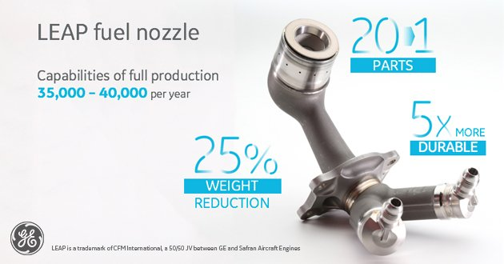
Resources needed:
Please specify the human resources required to set up and to run the case study. Do you need any external experiences to implement the case study? If yes, please specify.

