Share4.0
WoRkpackage report
WP3 – working base and pilot projects for share4.0

Version 1
IMSAS – J. Jerz
Date 16.05.2022

Table of contents / Inhalt
Table of contents / Inhalt 2
1 CT investigation of component 3D printed within Use Case 1 – LEAP engine fuel noozle 3

CT investigation of component 3D printed within Use Case 1 – LEAP engine fuel noozle

LEAP engine fuel noozle (Fig. 1) 3D printed within Use Case 1 by FOTEC Forschungs- und Technologietransfer GmbH has been investigated by Institute of Materials and Machine Mechanics of Slovak Academy of Sciences by Computed Tomography (CT) using Nikon XT H 225 ST:
- www.umms.sav.sk/6650-sk/nikon-xt-h-225-st/
- www.nikon.com/products/industrial-metrology/lineup/xray_ct/ct/xth225/
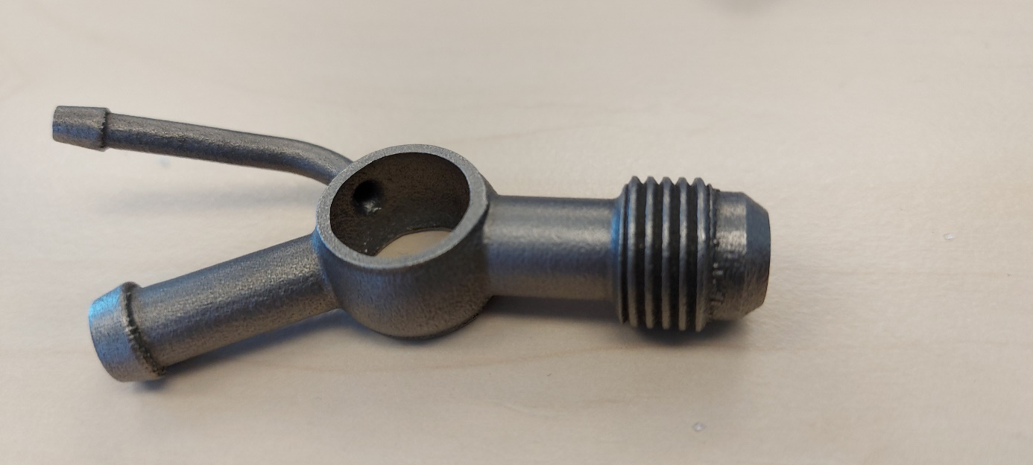
Figure 1 LEAP engine fuel noozle.
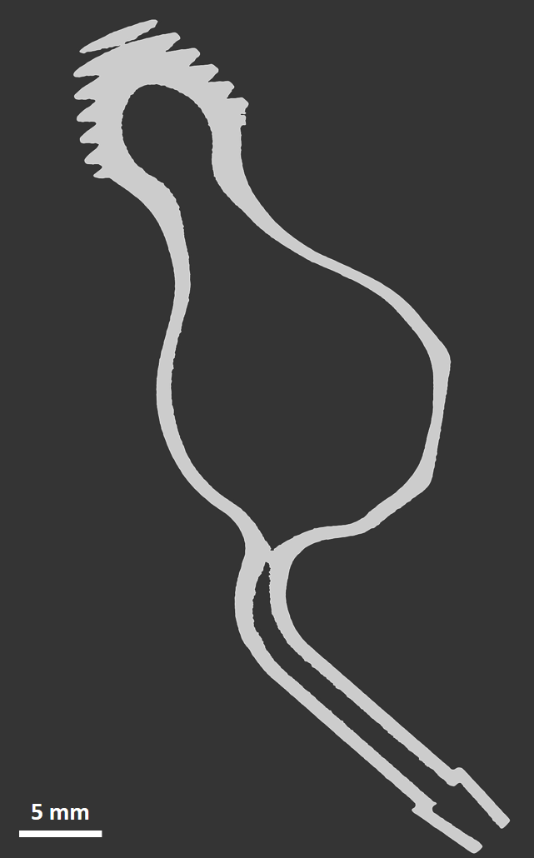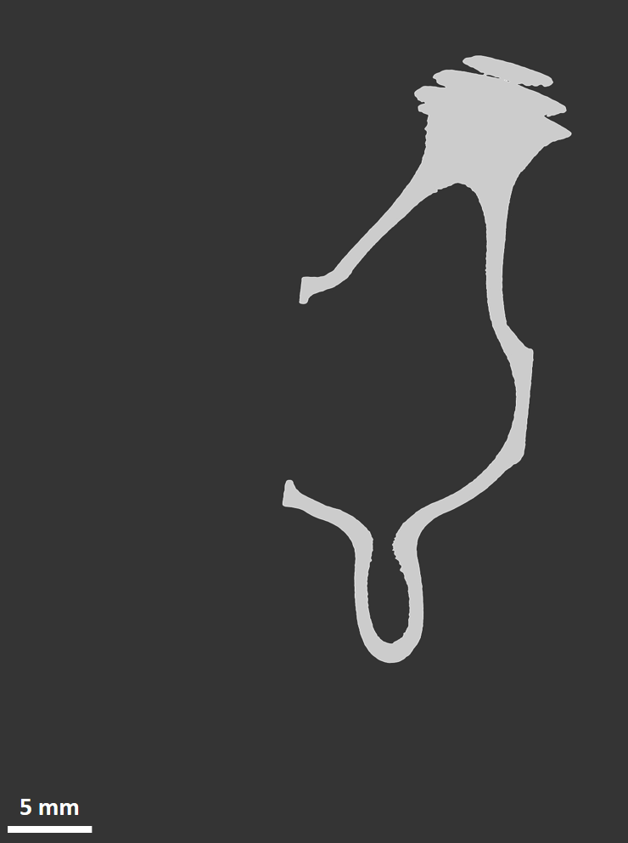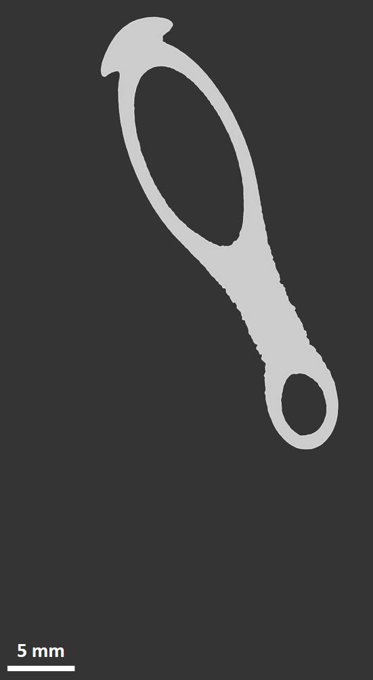
a) b) c)
Figure 2 Cross-sectional areas of LEAP engine fuel noozle.
Cross-sectional areas of LEAP engine fuel noozle in three perpendicular directions are displayed using CT in figure 2. As can be seen from figure 3, investigation using CT is the appropriate methodology for determining surface quality and detecting undesirable defects in the structure of parts produced by 3D printing.
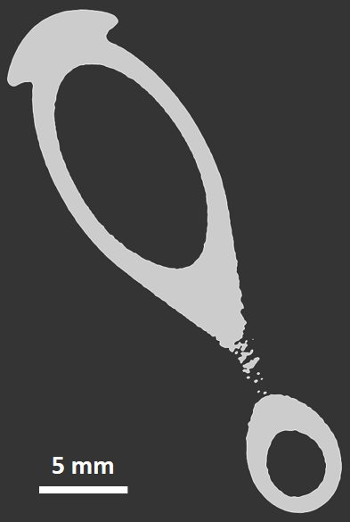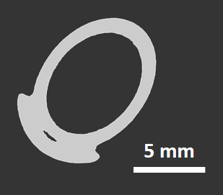
a) b) c)
Figure 3 Investigation of LEAP engine fuel noozle surface quality.

