SUSTAINABLE, RESILLIENT USE CASES
TEMPLATE to collect USE CASES
D3.3.2.9 Sustainable, resillient use cases

Version 1

Use Case 1
TITEL OF THE USE CASE: | Präzisionsrobotik

TOPIC: | Sustainable, resillient production

CONTACT INFORMATION
Partner organisation: | Technische Universität München
Contact person:
Address: | Boltzmannstr. 15  D - 85748 Garching  GERMANY
E-mail: | Info.am@ed.tum.de
Phone: | +49 8928915199

DESCRIPTION
Short summary of the Use Case:  Max.200 characters as promotional introduction | Due to their large working range, robotic manipulators have the potential to be used for high-precision non-contact manufacturing processes such as laser cutting or welding on large complex workpieces (Fig. a). However, most industrial manipulators are not capable of meeting the necessary accuracy requirements. Due to their flexible structures, they are subject to point-to-point positioning errors and, to a lesser extent, vibration errors. Vibration problems are particularly difficult to overcome. Many published solutions propose modifying the robot's own control system to overcome these problems. However, most modern control techniques require highly accurate models of the underlying system dynamics, which are quite difficult for robotic manipulators to obtain.
Detailed information on the Use Case:  Max.1000 characters about technical features – easy language | Main approaches to achieve this goal  The first uses acceleration feedback at the robot's mounting flange, using the inertial force of a voice coil actuator as a control variable (Fig. b). This setup allows us to use active vibration damping techniques for side-by-side sensor/actuator pairs. The system dampens the structural vibrations of the robotic manipulator, improving its tracking accuracy.  The second approach uses an additional set of actuators to move the process tool relative to the robot's mounting flange (Fig. c). This stabilization unit decouples the process tool from the robot and prevents the transfer of disturbances from the robot to the tool. For this to work, one needs a good estimate of the current position of the tool relative to the process surface, which is achieved through several types of sensors and sensor fusion.  The main challenge for both approaches is the coupling between the stabilization device and the robot's own structural dynamics. To design appropriate controls, a flexible multibody simulation of a generic robot manipulator was developed using measured data from our own CROPS harvesting robot and a UR10 robot. The simulation also uses models for the robot's electrical system, joint controls, and flexibilities in the robot's gears and joints. Recently, a prototype stabilization unit was developed that was able to reduce the trajectory tracking error of a UR10 robot from 1 mm to 10 microns.
Key achievements:  Results of the application for SME e.g. new market entry | Benefits for the collaboration space  Timely transfer options for direct, immediate use;  Strategic collaborations for optimization in production, serving assistance systems and resilience.
Further information:  Link to further information on the case study can be found | https://www.ipa.fraunhofer.de/de/referenzprojekte/Amadeus.html
Keywords related to your case study: | Precission, production, robots
Visual presentation:  Image (2000px wide recommended) and/or videeo | 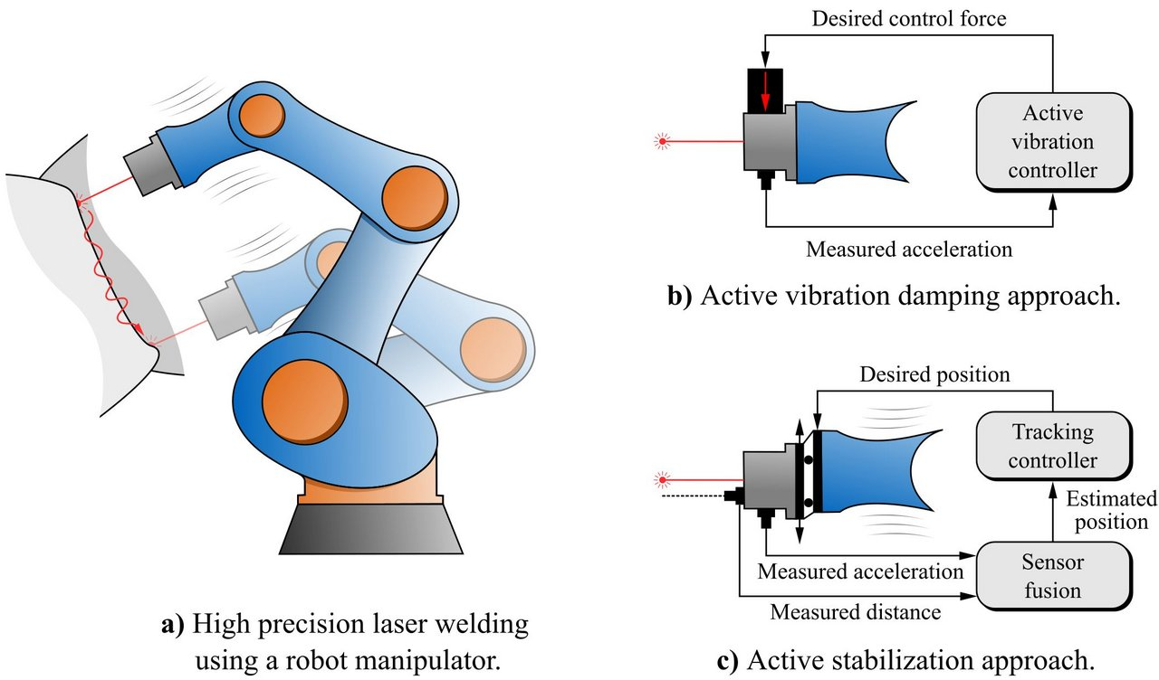
Resources needed:
Please specify the human resources required to set up and to run the case study. Do you need any external experiences to implement the case study? If yes, please specify.

