SUSTAINABLE, RESILLIENT USE CASES
TEMPLATE to collect USE CASES
D3.3.2.1 Sustainable, resillient use cases

Version 1
8th February 2022

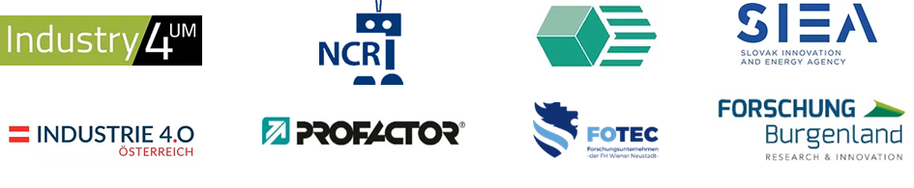

Use Case 1
TITEL OF THE USE CASE: | Conformal cooling

TOPIC: | Sustainable, resillient production systems

CONTACT INFORMATION
Partner organisation: | FOTEC Forschungs- und Technologietransfer GmbH.
Contact person: | Christoph Ackerl, MSc
Address: | Viktor Kaplan-Strasse 2, A-2700 Wiener Neustdt
E-mail: | Ackerl@fotec.at
Phone: | +43 2622 90333 281

DESCRIPTION
Short summary of the Use Case:  Max.200 characters as promotional introduction | Cooling close to the contour can significantly reduce cycle times during injection molding. It also allows the inserts to be made from different materials than before. These materials allow longer service lives of the injection molding inserts.
Detailed information on the Use Case:  Max.1000 characters about technical features – easy language | In the injection molding process, very large quantities of the same parts are produced. The cycle time indicates how long it takes for a part to be manufactured. If this time can be reduced, more parts can be produced in the same time and the costs per part fall. An additional cost factor is the service life of the insert. This means how many parts can be produced with a mold until it is worn out that it has to be replaced. No parts can be produced during the exchange, so costs are created not only by the production of the new insert, but also by the downtime. By changing the material, the downtime could be doubled (3 million to 6 million) The new material used has a lower thermal conductivity, which normally leads to a longer cycle time. By using cooling channels close to the contour, it was even possible to reduce the cycle time, resulting in a break-even point at approx. 1.5 million parts.
Key achievements:  Results of the application for SME e.g. new market entry | reducing production costs of injection molded parts,
Further information:  Link to further information on the case study can be found | (FOTEC)
Keywords related to your case study: | conformal cooling, tool insert
Visual presentation:  Image (2000px wide recommended) and/or videeo | 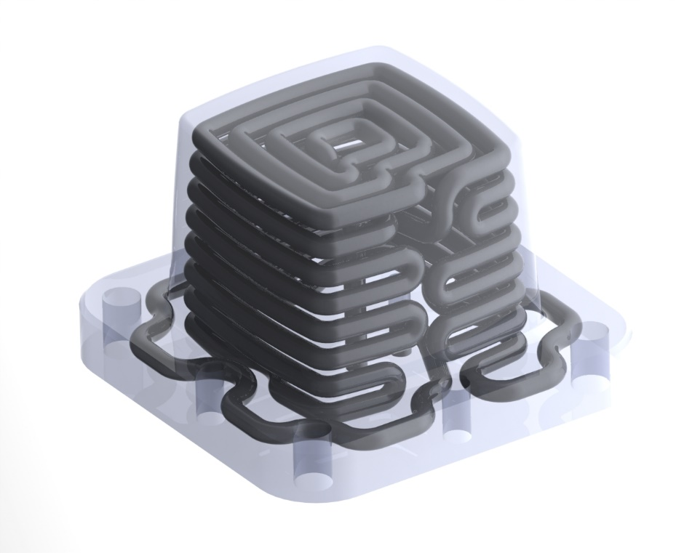
Resources needed:
Please specify the human resources required to set up and to run the case study. Do you need any external experiences to implement the case study? If yes, please specify.

