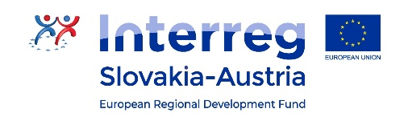
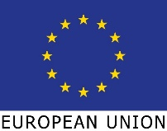

Share4.0
WoRkpackage report
D3.2.1.4.4 – target group workshop

Version 1
Company – Person
Date 17.03.2022

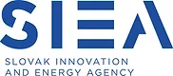
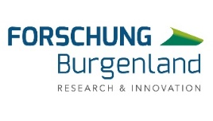
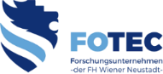
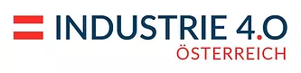

Table of contents / Inhalt
Table of contents / Inhalt 2
1 Workshop with target group and decision makers 3
1.1 "Additive Fertigungstechnologien" - Master's Degree Program 3

Workshop with target group and decision makers

" Additive Manufacturing Technologies " - Master's Degree
Projectpartner: FOTEC – DI Christoph Ackerl
Type: Lecture
Location: University of applied sciences Wiener Neustadt
Date: 17.03.2022
- Ajamieh Mohannad
- Forsthuber Markus
- Gigov Boris
- Leitner Paul
- Mollner Peter
- Strummer Moritz
- Vidovic Josip

Agenda
- Job preparation / traceability
- In-situ monitoring
- Test methods and samples, errors and their effects

Job preparation / traceability
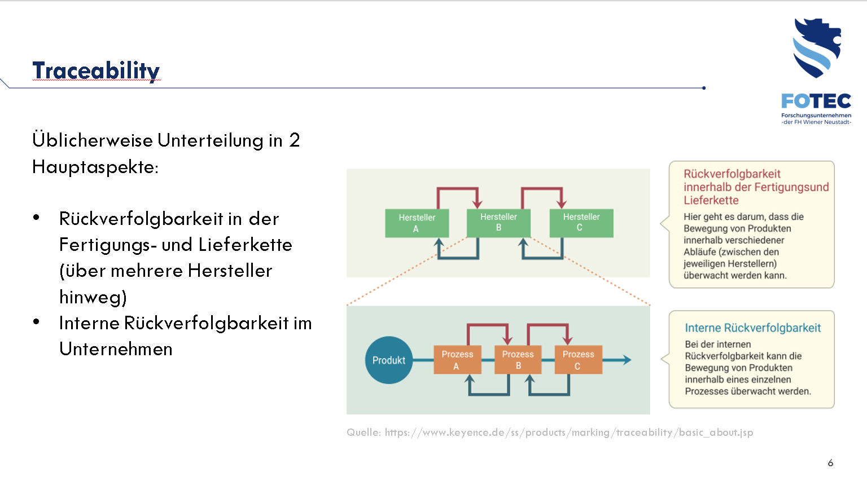
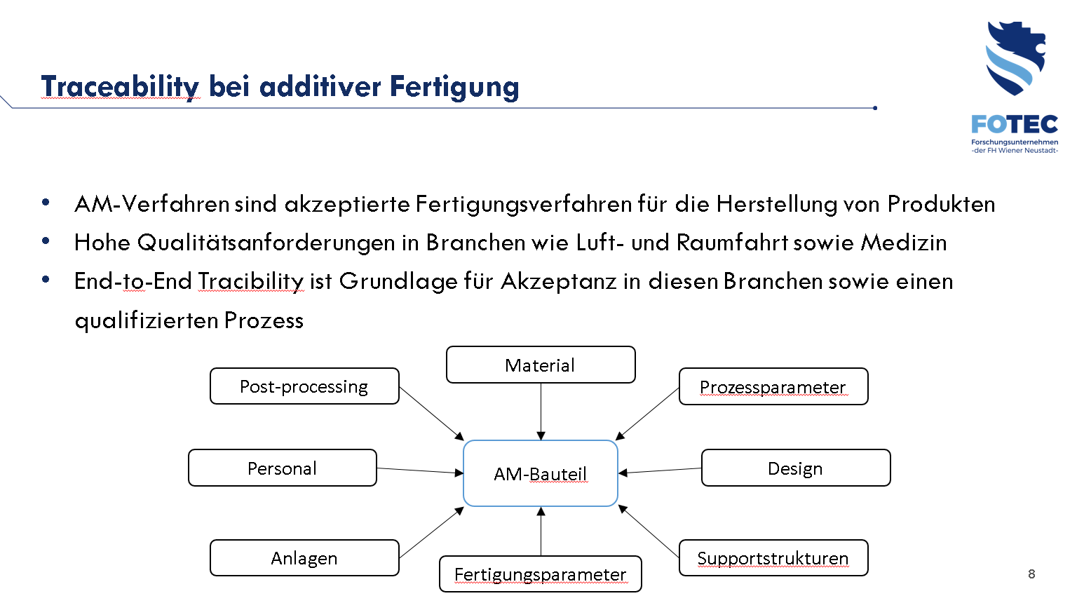
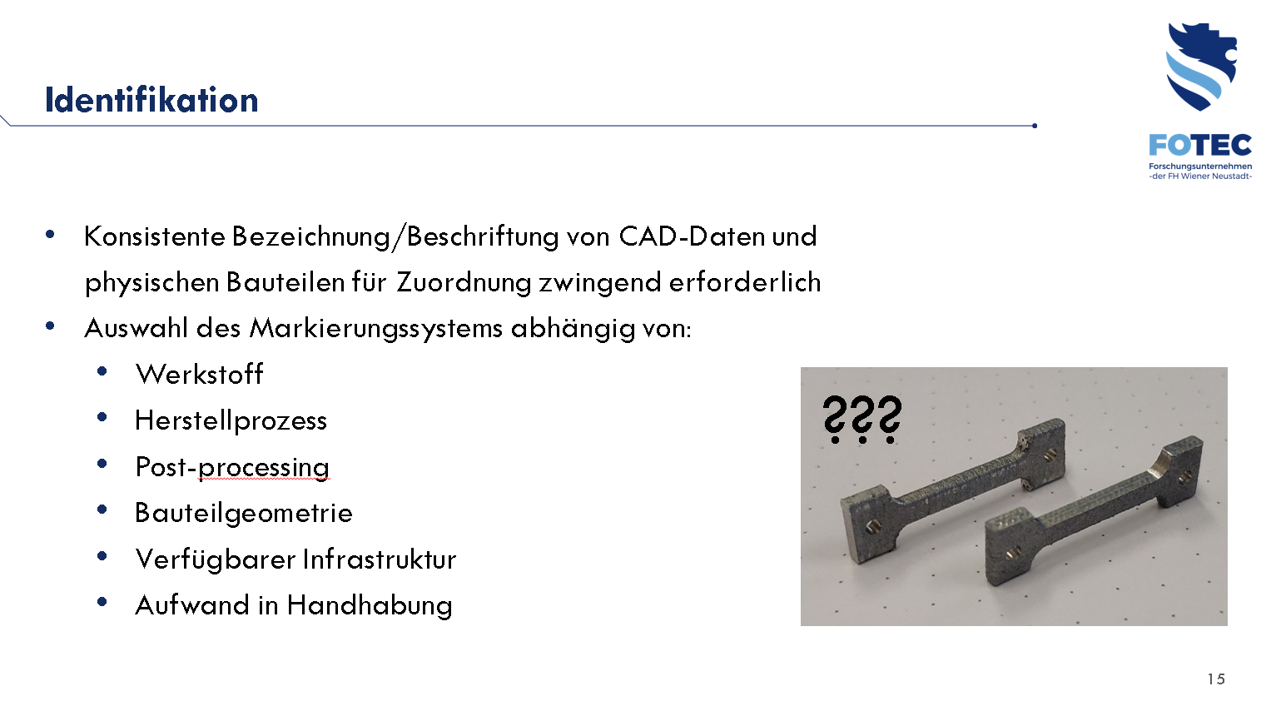

In-situ monitoring
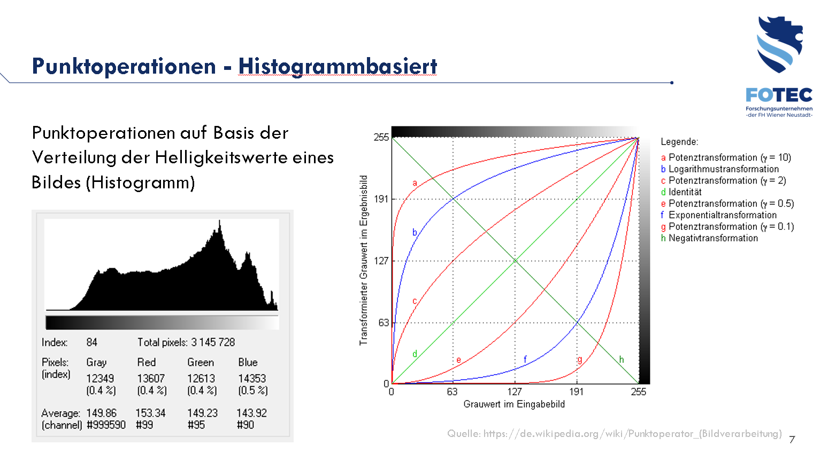

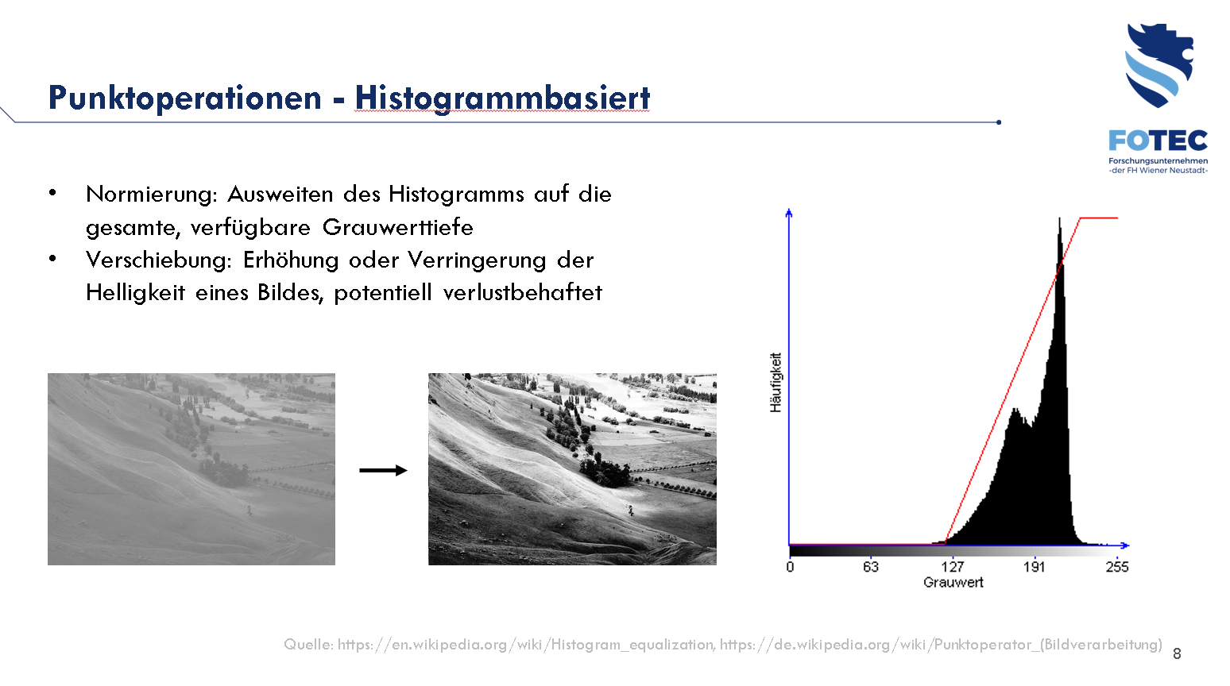
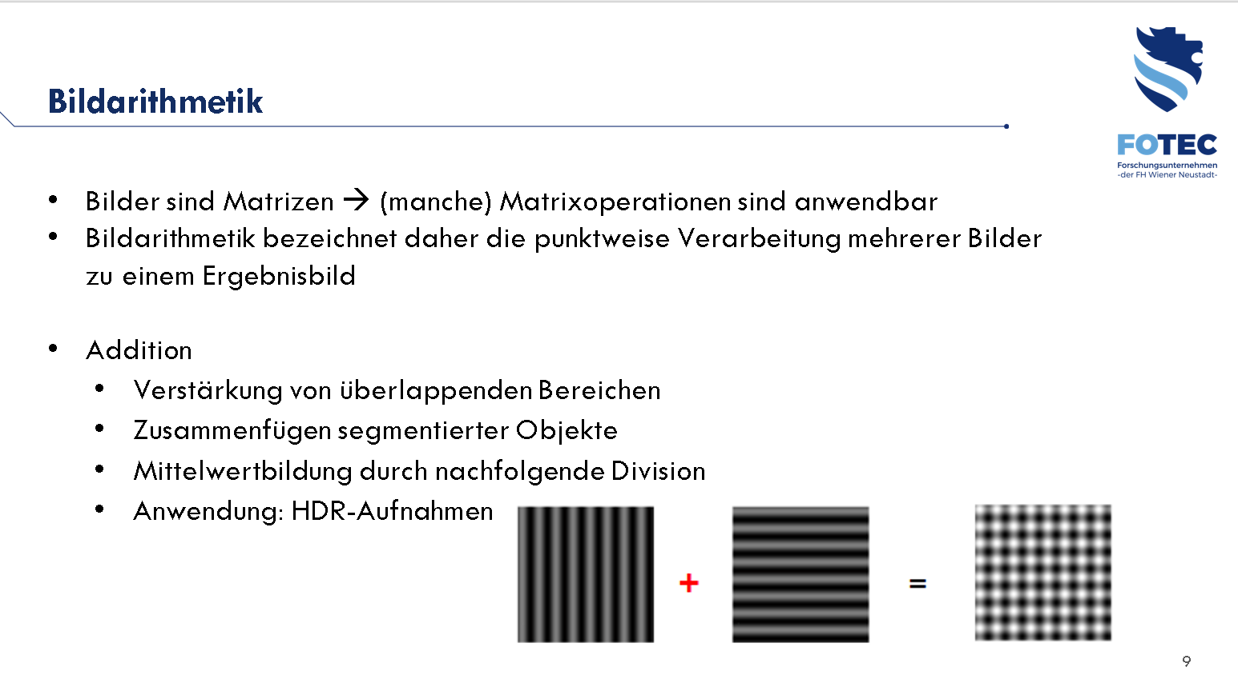

Test methods and samples, errors and their effects

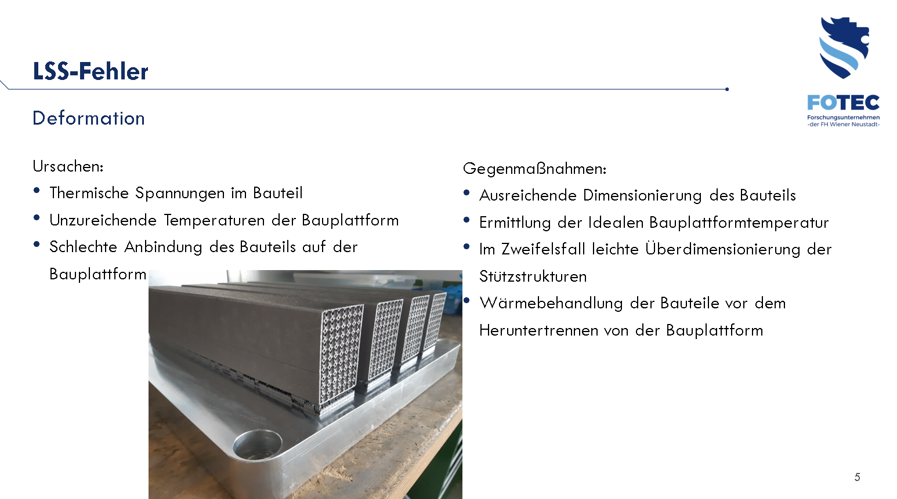

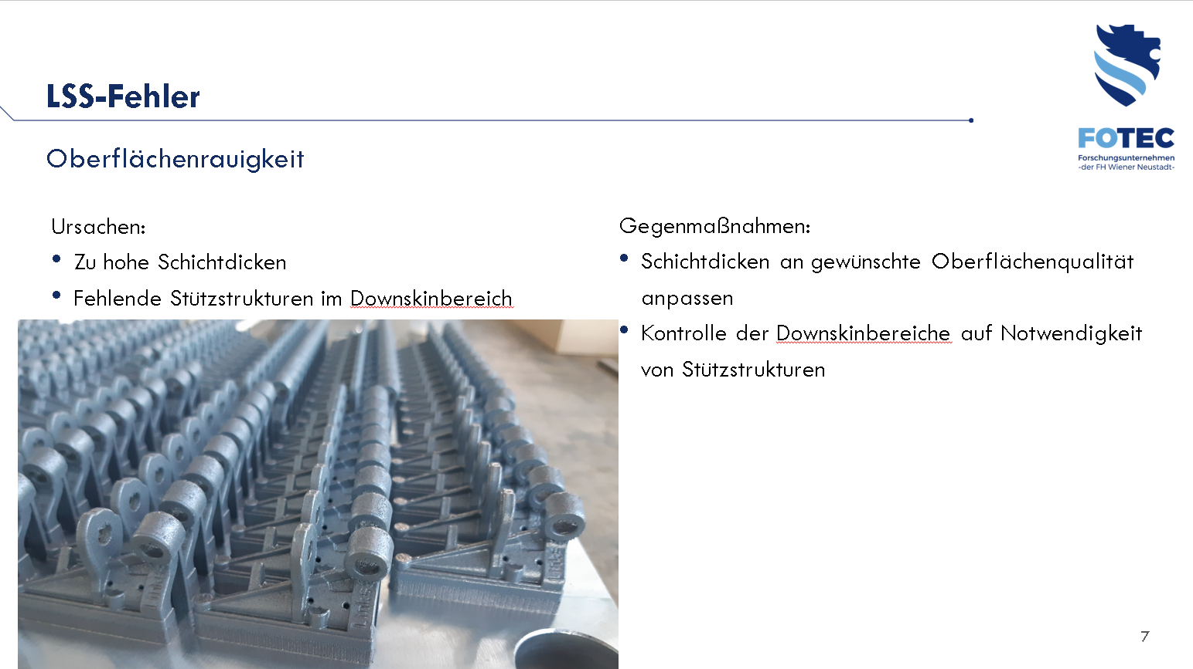

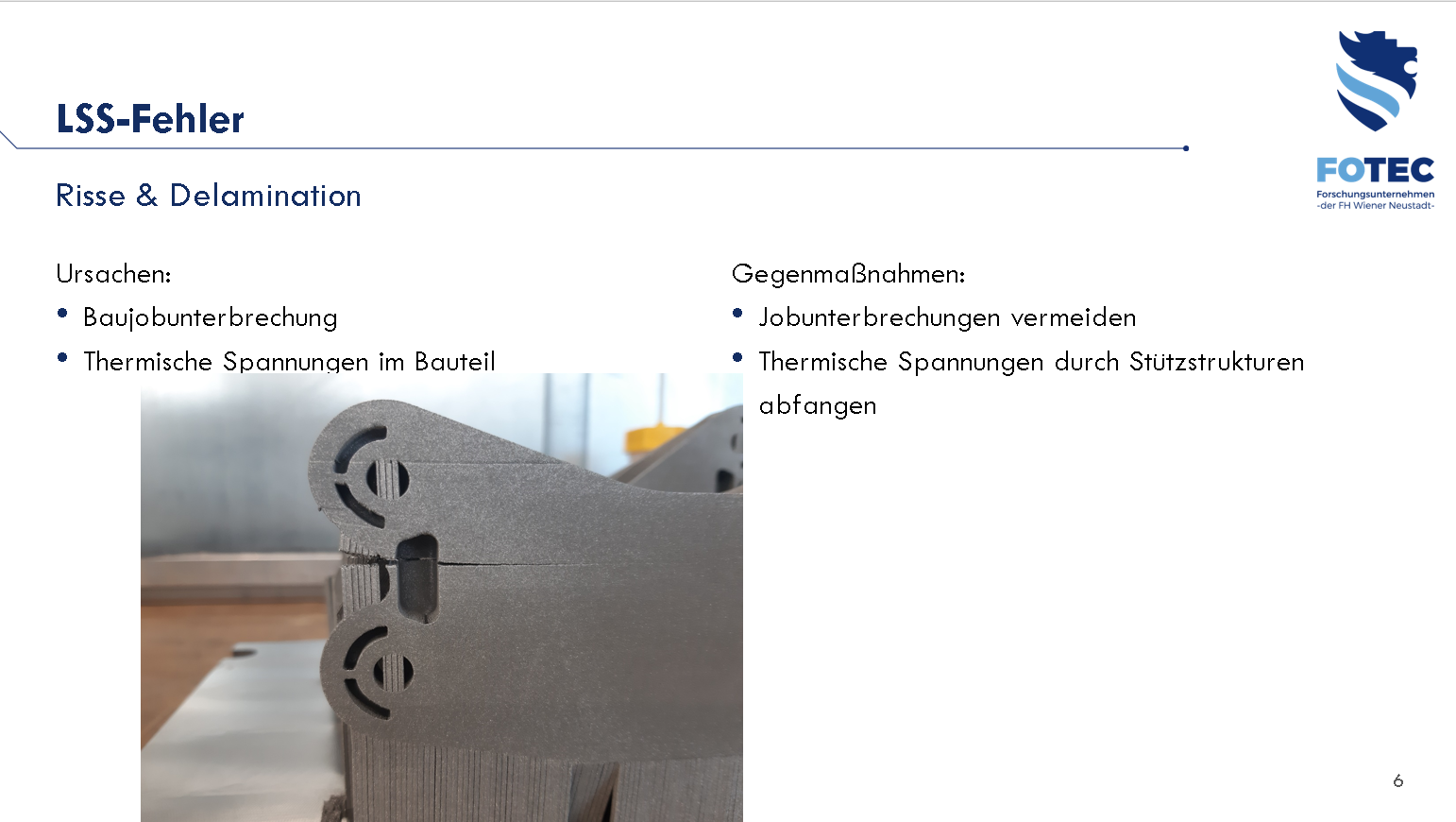

" Additive Manufacturing Technologies " - Forschungsfest
Projectpartner: FOTEC – DI Thomas Schlauf, DI Markus Hohlagschwandtner MSc
Type: Exhibition
Location: Palais Niederösterreich, Herrengasse 13, 1010 Wien
Date: 30.09.2022
- Different visitors (politics, stakeholders, companies and private)

Dissemination
- D3.3.1.1 Criteria catalaog
- D3.3.1.3 Pilot Action documentation

