



Share4.0

WoRkpackage report

D3.3.1.4.2 – IMPROVE! ENDEVENT EXHIBITION

Version 1  
Company – Person

Date 15.09.2022

\\fhbgld.at\Home_FB\FB\fbtkremsner\ProfileData\Desktop\IMPROVE_Logos PPs\IMPROVE_Logos PPs\PP3_PROFACTOR\PROFACTOR_logo.jpg

# Table of contents / Inhalt

[Table of contents / Inhalt 2](#_Toc95195610)

[1 Header 3](#_Toc95195611)

# Workshop with target group and decision makers

## "Additive Fertigungstechnologien" - Master's Degree Program

Projectpartner: FOTEC – Dr. Markus Hatzenbichler  
Type: Lecture  
Location: University of applied sciences Wiener Neustadt  
Date: 17.03.2022

# Physical/ digital demo example workshop

## DIH-OST "3D Konstruktion und Simulation von Share 4.0

Projectpartner: FOTEC – Dr. Markus Hatzenbichler  
Type: Workshop  
Location: Teams  
Date: 03.02.2022  
  


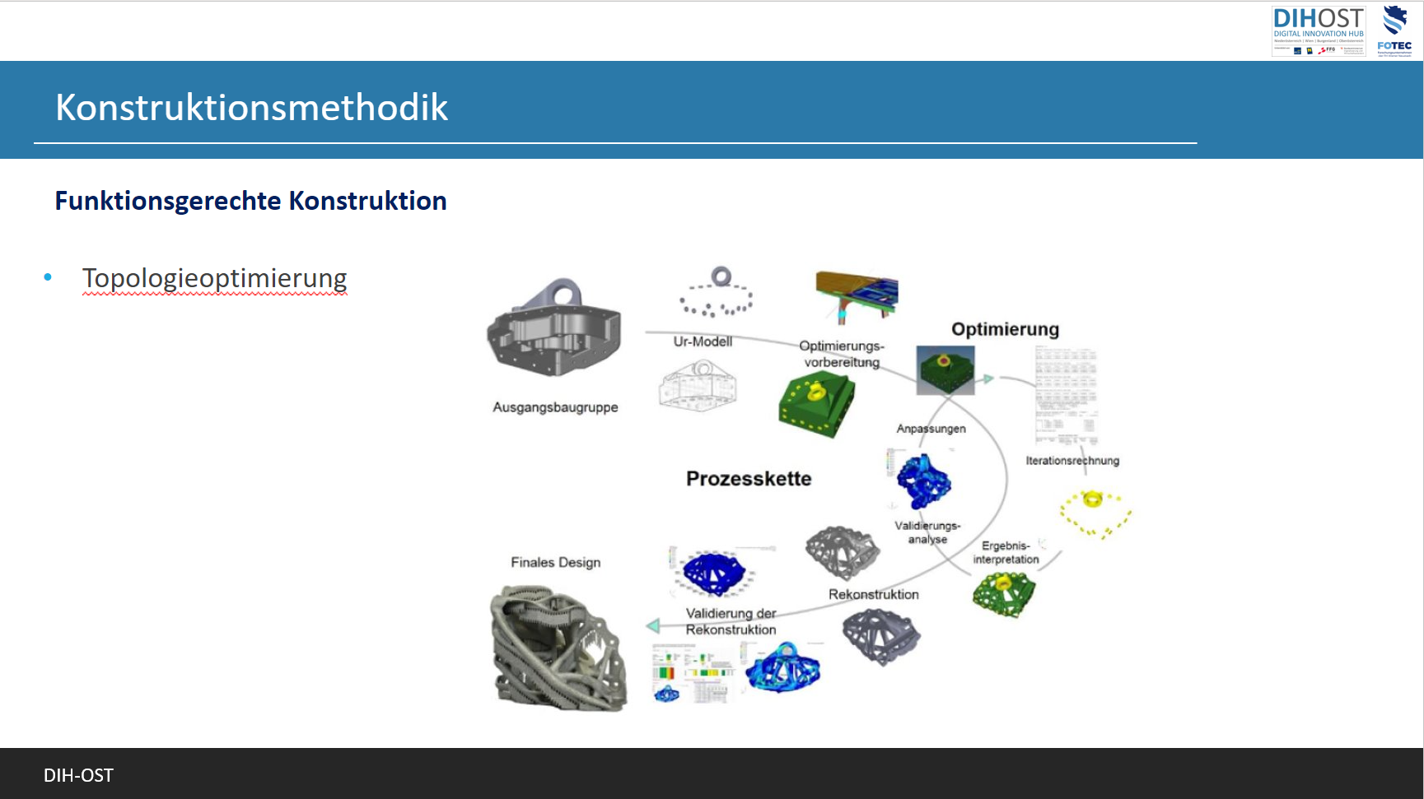

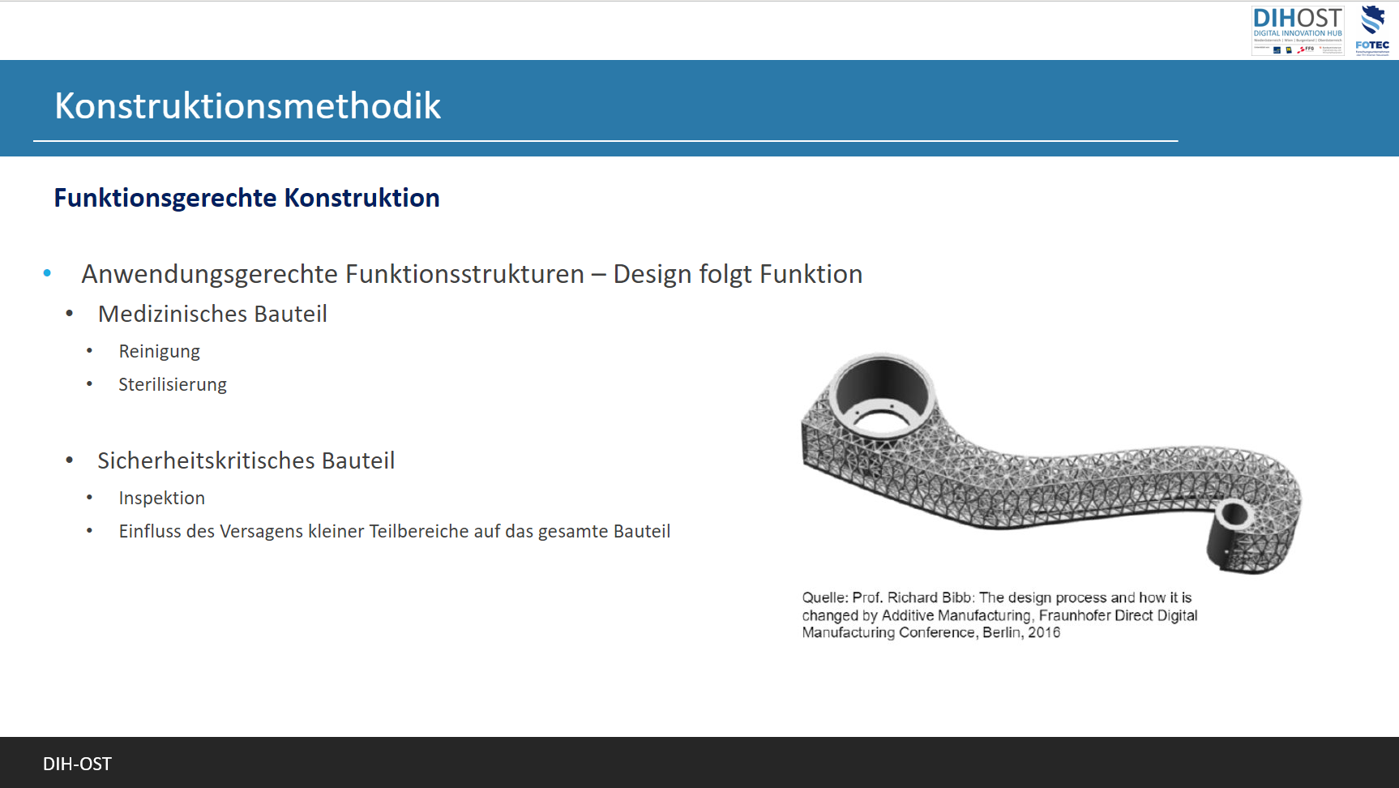

## IMPROVE! Project End Event

Projectpartner: FOTEC / PROFACTOR   
Type: Exhibition   
Location: TFZ Wiener Neustadt  
Date: 15.09.2022

### Attendees

#### Physically

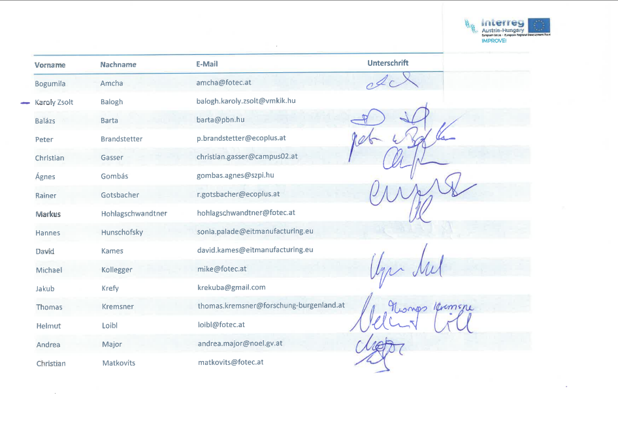

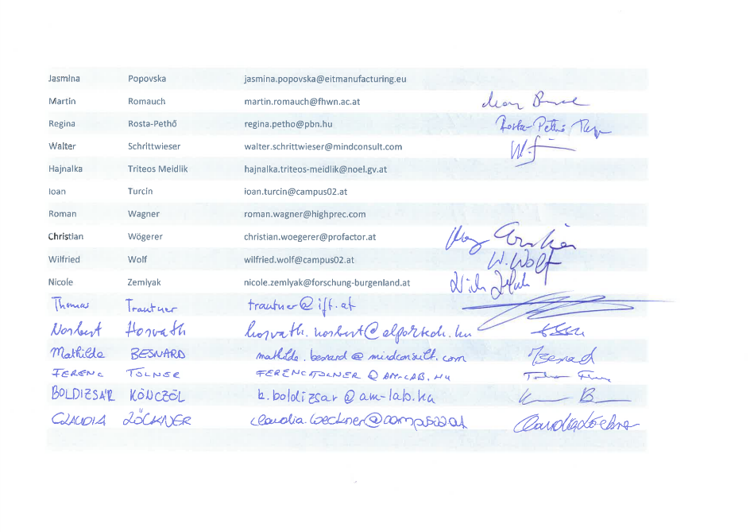

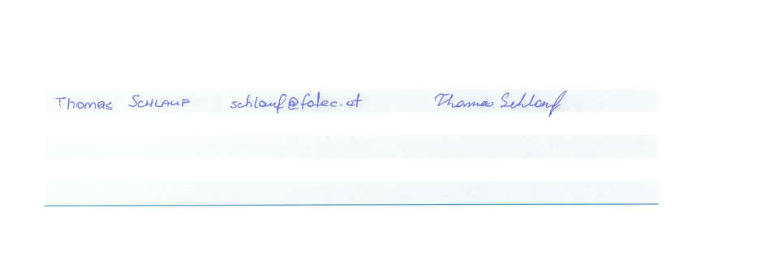

#### Teams

|  |  |  |
| --- | --- | --- |
| 1. Zusammenfassung |  |  |
|  |  |  |
| Teilnehmende Teilnehmer\*innen | 44 |  |
| Startzeit | 15.9.22, 09:15:56 |  |
| Endzeit | 15.9.22, 23:45:51 |  |
| Besprechungsdauer | 14Std. 29Min. 5Sek. |  |
| Durchschnittliche Anwesenheitszeit | 2Std. 39Min. 2Sek. |  |
|  |  |  |
| 2. Teilnehmer |  |  |
| Name | Erster Beitritt | Letztes Verlassen |
| Markus Hohlagschwandtner (MHo) | 15.9.22, 09:16:05 | 15.9.22, 14:55:59 |
| Bódi Vanessza Evelin | 15.9.22, 09:30:01 | 15.9.22, 12:00:10 |
| Lilik Gábor - VIE | 15.9.22, 09:34:12 | 15.9.22, 10:42:16 |
| Sailer Patrizia | 15.9.22, 09:50:18 | 15.9.22, 12:45:35 |
| Rosta György (Vendég) | 15.9.22, 09:52:21 | 15.9.22, 14:27:23 |
| Porkoláb Gábor (Vendég) | 15.9.22, 09:54:40 | 15.9.22, 11:46:39 |
| Bloa Bui | 15.9.22, 09:54:51 | 15.9.22, 11:40:18 |
| Schindler Markus | 15.9.22, 09:56:25 | 15.9.22, 12:49:14 |
| Horvath Christian | 15.9.22, 09:56:57 | 15.9.22, 14:56:11 |
| Puchegger Markus | 15.9.22, 09:57:22 | 15.9.22, 15:03:24 |
| Marcus (Gast) | 15.9.22, 09:57:25 | 15.9.22, 23:45:51 |
| Klikovits Christoph | 15.9.22, 09:57:47 | 15.9.22, 13:26:26 |
| Pichler Harald | 15.9.22, 09:58:48 | 15.9.22, 13:40:18 |
| Medwenitsch Karina | 15.9.22, 09:59:10 | 15.9.22, 12:31:45 |
| Gnauer Clemens | 15.9.22, 09:59:14 | 15.9.22, 14:28:34 |
| Pllana Sabri | 15.9.22, 09:59:23 | 15.9.22, 10:09:16 |
| Millendorfer Monika | 15.9.22, 09:59:38 | 15.9.22, 15:03:48 |
| Knopf Silvia | 15.9.22, 09:59:47 | 15.9.22, 11:55:51 |
| Jessica Rainprecht | 15.9.22, 09:59:50 | 15.9.22, 12:11:59 |
| Stolavetz Christina | 15.9.22, 10:00:24 | 15.9.22, 10:29:08 |
| Schönfeldinger Marion | 15.9.22, 10:00:40 | 15.9.22, 19:37:23 |
| Lilik Gábor (Vendég) | 15.9.22, 10:00:54 | 15.9.22, 10:01:49 |
| Natalie | 15.9.22, 10:00:58 | 15.9.22, 10:29:41 |
| Prochazka Andrea | 15.9.22, 10:01:19 | 15.9.22, 12:33:30 |
| Hauer Katharina | 15.9.22, 10:02:11 | 15.9.22, 11:15:37 |
| Pfeiffer Christian | 15.9.22, 10:02:24 | 15.9.22, 15:03:25 |
| Binder Johann | 15.9.22, 10:07:09 | 15.9.22, 11:26:19 |
| Natália Kovács (Gast) | 15.9.22, 10:08:18 | 15.9.22, 12:54:02 |
| Teresa Tschürtz | 15.9.22, 10:09:28 | 15.9.22, 12:16:31 |
| Sophie Müller | 15.9.22, 10:09:42 | 15.9.22, 12:21:44 |
| Hamedl Marlene | 15.9.22, 10:13:24 | 15.9.22, 11:37:08 |
| denise | 15.9.22, 10:15:51 | 15.9.22, 10:38:16 |
| Gáspár Júlia (Simon-Trans) (Vendég) | 15.9.22, 10:18:18 | 15.9.22, 15:34:49 |
| Keding Marcus | 15.9.22, 10:20:18 | 15.9.22, 12:05:04 |
| Kremsner Thomas | 15.9.22, 10:20:56 | 15.9.22, 15:00:23 |
| Natalie | 15.9.22, 10:32:36 | 15.9.22, 11:44:10 |
| Gyulai Tamás | 15.9.22, 10:37:45 | 15.9.22, 13:59:41 |
| Denise | 15.9.22, 10:40:44 | 15.9.22, 11:55:48 |
| Kerék Anikó | 15.9.22, 10:50:13 | 15.9.22, 13:32:57 |
| Vastag Erika | 15.9.22, 10:50:32 | 15.9.22, 10:52:42 |
| Hofmann Marcus | 15.9.22, 10:51:38 | 15.9.22, 11:28:01 |
| Schattovits Mario | 15.9.22, 11:03:14 | 15.9.22, 11:55:34 |
| Jennifer | 15.9.22, 11:24:14 | 15.9.22, 11:54:24 |
| Gönczi Richárd (Vendég) | 15.9.22, 13:56:04 | 15.9.22, 15:10:55 |

### Photo Documentation

